PRACTICAL INFORMATION
Symposium October 30 – November 2, 2022
BETHESDA Conference Center
Rømersgade 17, Copenhagen K.
Evening Prayer Mon/Tues in Martinskirken, Martinsvej 4

Registration by 1 October 2022
to mail@lutherakademi.org

Participant fee 1,050 DKK for the entire symposium. Member price 900 DKK. Price individual for attending only lectures is 85 DKK per lecture.

NELA's Danish account, konto: 9682-0000854646
IBAN-Kontonummer: DK5296820000854646.
BIC-kode: NRNEDK21.
Payment due with registration.

Meals may be offered during the symposium.
Information will later be given at our web-page www.lutherakademi.org/NELA2022.htm

SUGGESTIONS for lodging
IBSENS HOTEL, Vendersgade 23, København K. About 5
min. walk to Bethesda.
CABINN Scandinavia Hotel, Vodroffsvej 55, Frederiksberg.
About 20 min. walk to Bethesda, or
Metro Forum -> Nørreport 3 min. + 7 min walk.
NELA Board members
Norway
Erik A.H.Okkels (chairman),
Knut Alfsvåg, Jan Bygstad.
Finland
Hannu Lehtonen,
Halvar Sandell (treasurer).
Sweden:
Fredrik Sidenvall, Daniel Johansson.
Denmark
Karsten Christensen (secretary), Leif G. Jensen.

DIRECTIONS

Kursuscenter

Bethesda

Rømersgade 17
To Bethesda Conference Center:
* Metro from CPH Airport to Nørreport Metro
* S-train from Copenhagen Central STA

to Nørreport Station
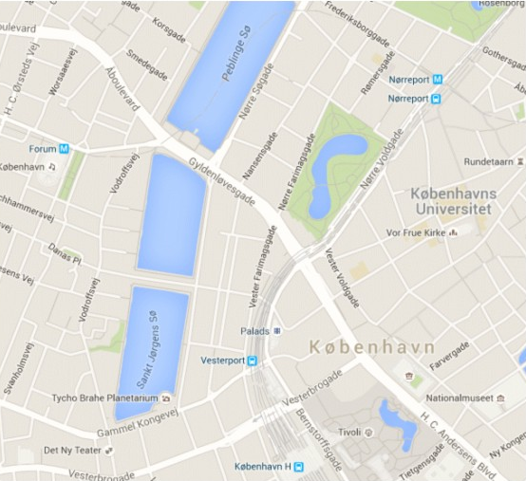

Ibsens Hotel

Evening Prayer man/tir

i Martinskirken

Martinsvej 4

Cabinn Hotel

INFO on NELA
North European Luther Academy, founded in August 1998, arranges an annual theological symposium in Northern Europe.
The members of the board of NELA commit themselves to following statements of foundations: Our mission is, on the foundation of The Holy Scripture and in faithfulness to the Evangelical-Lutheran confession (The Book of Concord), to pursue dynamic theological research and education, that rediscovers treasures in the theological heritage of our Churches and confronts the biblical truths with today's questions.
Read more about North European Luther Academy:
https://www.facebook.com/lutherakademi/
http://www.lutherakademi.org/

Welcome to the NELA-symposium!
Final version, August 26, 2022

Christ
in the Old Testament
NELA 2022
Symposium arranged by
North European Luther Academy
in Copenhagen
October 30 – November 2, 2022

Christ in the Old Testament
The Evangelists testify that Jesus taught his disciples that he is the Christ, whom God promised in the Old Testament.
”You search the Scriptures because you think that in them you have eternal life; and it is they that bear witness about me.” (Joh 5:39).
Then he opened their minds to understand the Scriptures, and said to them, “Thus it is written, that the Christ should suffer and on the third day rise from the dead, and that repentance for the forgiveness of sins should be proclaimed in his name to all nations, beginning from Jerusalem. You are witnesses of these things..” (Lk 24:45-48)
We have invited theologians and pastors who have examined the Scriptures and found Christ, as Jesus and the Apostles show him to us in the New Testament.
This year's NELA symposium offers a bouquet of
teaching and theological research on "Christ in
The Old Testament” based on trust in the
Testimony of Holy Scripture.

SUNDAY, October 30th 2022
Arrival at Bethesda from 18.00.
19.00: Welcome and Presentation
19.30: Do you understand what you are reading: On Luther’s and Lutheran use of the OT (Jan Bygstad)
20.30: Coffee / tea
21.00: Evening Prayer

MONDAY, October 31st 2022
09.00: Morning devotion in Bethesda
09.30: An Introduction to the Presence of the Son before Christ (Charles A Gieschen)
10.45: Coffee / tea / fruit
11.15: New Testament Interpretations of Old Testament Theophanies (Charles A Gieschen)
12.30: Lunch
14.30: Justification and Salvation in the Old Testament (Carsten Vang)
15.30: Coffee / tea / fruit
16.00: Christ in the Psalms (Mats Eskhult)

17.15: NELA’s annual meeting
18.30: Supper
19.30: The Use and Understanding of The Old Testament in the catechesis (Egil Sjåstad)
20.30: Coffee / tea
21.15: Evening Prayer (in Martinskirken, Martinsvej 4)

TUESDAY, November 1st 2022
09.00: Morning devotion in Bethesda
9.30: Thinking about marriage with Luther
(Brandt Klawitter)
10.45: Coffee / tea / fruit
11.15: Divine conversations: Trinitarian Readings of the Old Testament in Early Christianity (Daniel Johansson)
12.30: Lunch
14.30: The decay of the biblical narrative - the hermeneutics of the Enlightenment and its
consequences (Knut Alfsvåg)
15.30: Coffee / tea / fruit
16.00-17.00: Panel discussion
18.30: Supper
19.30: Guidance for Preaching and Teaching Christ from the Old Testament (Charles A Gieschen)
20.30: Coffee / tea
21.15: Evening Prayer (in Martinskirken, Martinsvej 4)

WEDNESDAY, November 2nd 2022
09.00: Morning devotion in Bethesda
09.30: The story of Christ's suffering - interpreted and preached from the Old Testament: About the Early Lutheran passion sermons (Torbjörn Johannson)
10.45: Coffee / tea
11.15: Jacob’s God – Christ in the Old Testament
(Jan Bygstad)
12.15: Closing by NELA’s chairman
12.30: Lunch and departure

Lectures are held in a Scandinavian language or in English. Simultaneous translation from Scandinavian to English is available.
SPEAKERS
Dr. Knut Alfsvåg
Professor of systematic theology,
VID Specialized University, Stavanger

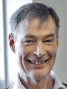
Jan Bygstad, D.D.
Pastor in DELK, Bergen
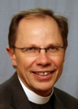
Dr. Charles A. Gieschen
Professor at Concordia Theological Seminary, Ft. Wayne
Teol. dr. Torbjörn Johannson
Lektor and Rector at
Lutheran School of Theology in Gothenburg.

PhD. Brandt Klawitter
Associate Professor at NLA and pastor in the Evangelical – Lutheran Confessional Church (ELBK) Sweden/Norway.
Carsten Vang
Associate Professor,
Lutheran School of Theology in Aarhus

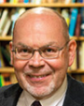
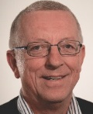
Docent em. Egil Sjaastad
Tidl rektor for Fjellhaug skoler og førstelektor i praktisk teologi Fjellhaug Int. Høgskole
Mats Eskhult, professor emeritus i semitiska språk vid Uppsala universitet
Daniel Johansson, lektor i Nya testamentet på Församlingsfakulteten i Göteborg

